**Revise part 2**

<http://mrgloo.com/storytelling/phase_3_3_group.php>



階段三：個人和小組作品反思

此頁面你會看到專屬於你在平台上的號碼是〔x〕號。

請點選「新增討論」，在「新增成員」區，加入組員的號碼後，你和小組成員即可在各自的帳號看到彼此寫得個人和小組作品的反思。

<http://mrgloo.com/storytelling/phase_3_3_add_group.php>

階段三：數位敘事作品的個人和小組反思內容



Add your new reflection here

請寫下小組作品共同反思的內容

請點選「新增討論」，在「新增成員」區，加入組員的號碼後，你和小組成員即可在各自的帳號看到彼此寫得個人和小組作品的反思。

<http://mrgloo.com/storytelling/menu.php>

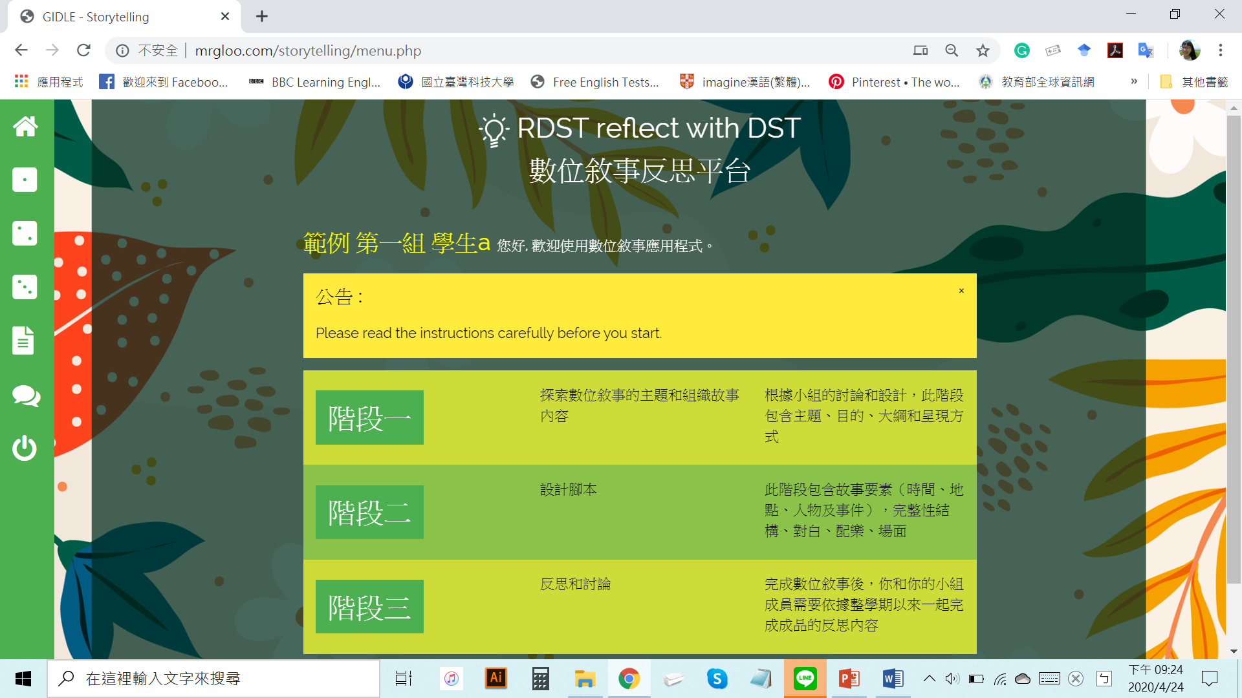

個人和小組作品反思

<http://mrgloo.com/storytelling/phase_1_1_step1.php>

Hi, Iqbal.

I want to change the color and font (bold) of Heading and Subheading.

And the page’s sentences looks crowded so I want to make spance between the prompt’s subheading and last sentence

<http://mrgloo.com/storytelling/phase_1_1_step2.php>

<http://mrgloo.com/storytelling/phase_1_1_step3.php>

<http://mrgloo.com/storytelling/phase_2_1.php>

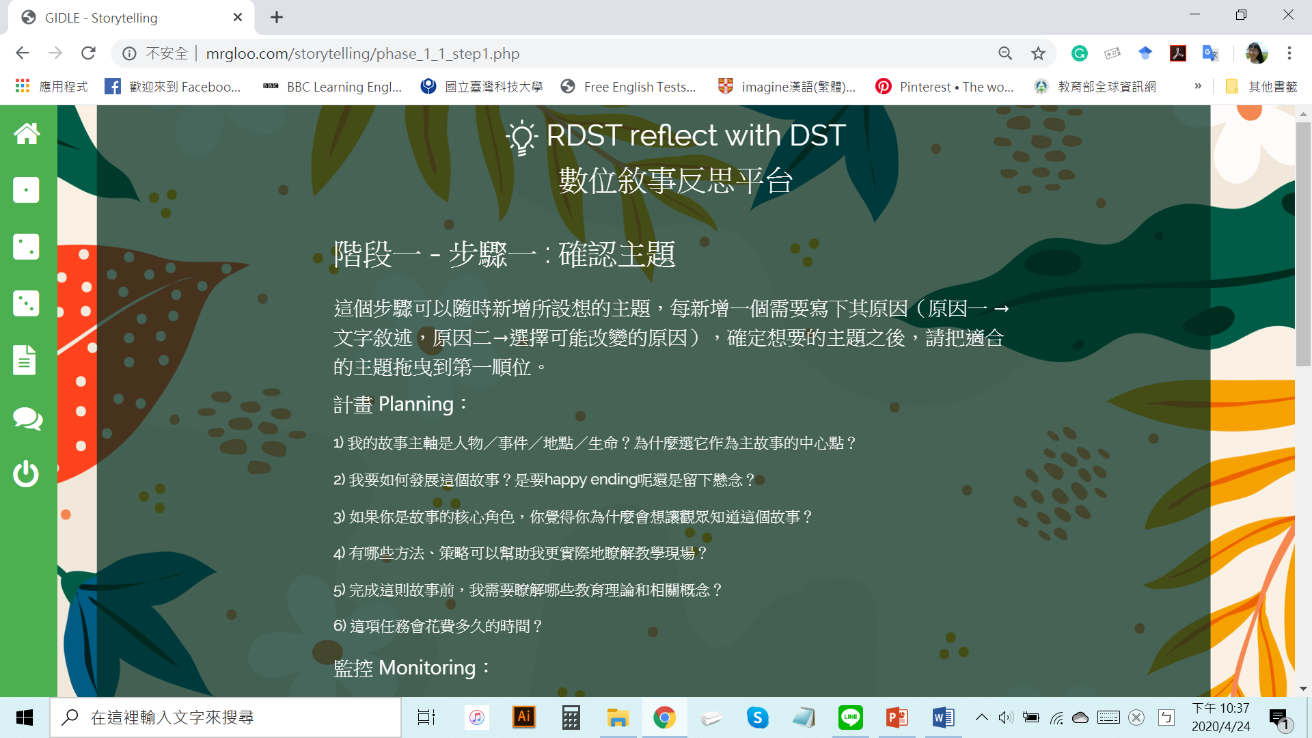

please make space between two sentences, the reason why I want to adjust is all of sentences look crowded, haha

Heading → make it bold → font color (change white into yellow or red?? )

subheading → make it bold → font color (change white into yellow or red?? )

I’m not sure which color would be best to read ^^

